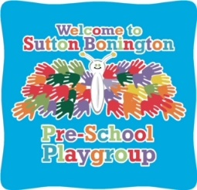

Sutton Bonington

Pre-School Playgroup Prospectus

Ofsted Certificate of Registration Number - 253433

How to find us:

Sutton Bonington Pre-school Playgroup
Old School Rooms, Bucks Lane
Sutton Bonington, Loughborough
Leics LE12 5PB

Mobile: 07977 545702
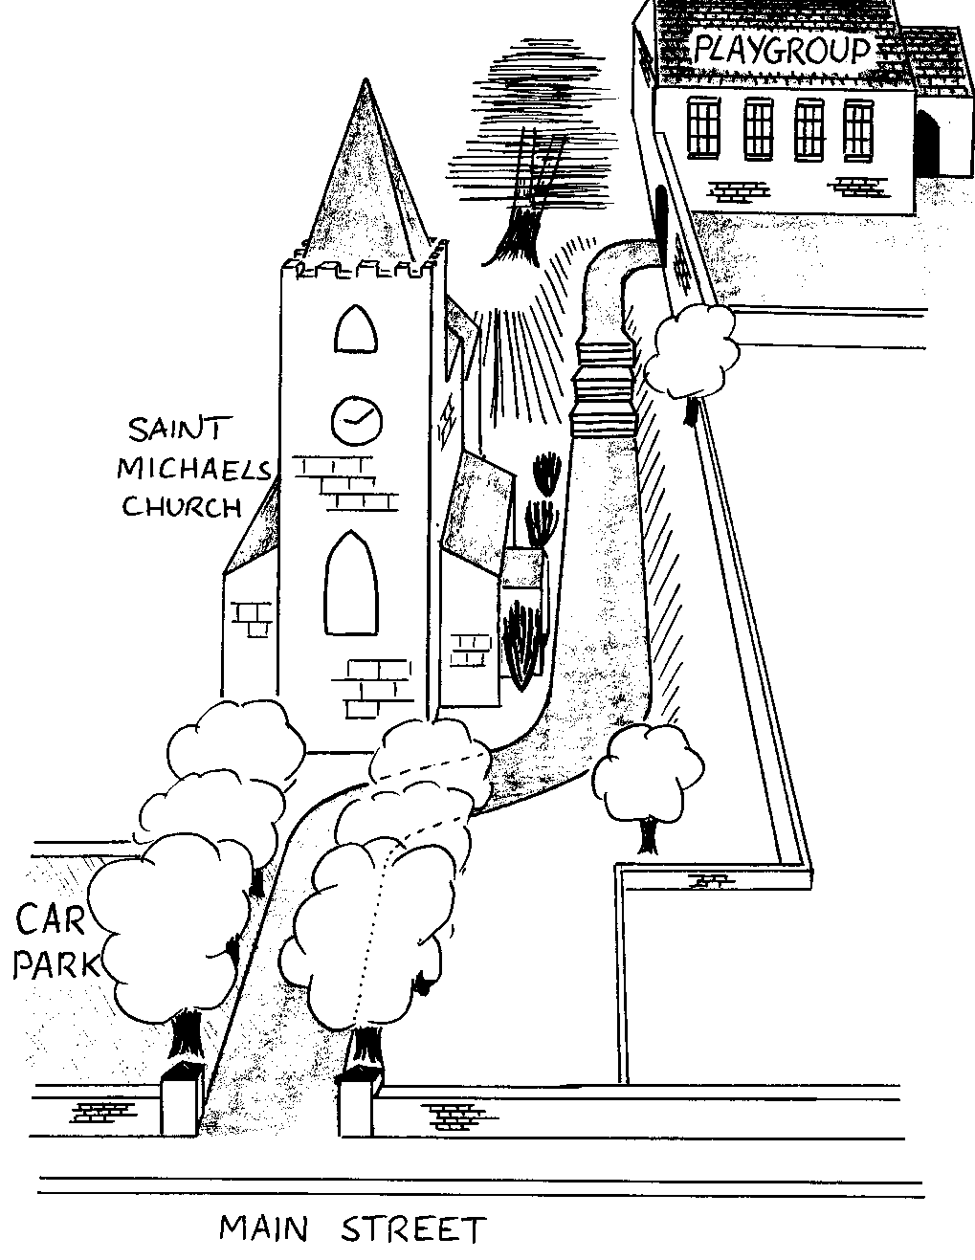
E-mail: info@suttonboningtonplaygroup.org
Internet : www.suttonboningtonplaygroup.org

WELCOME

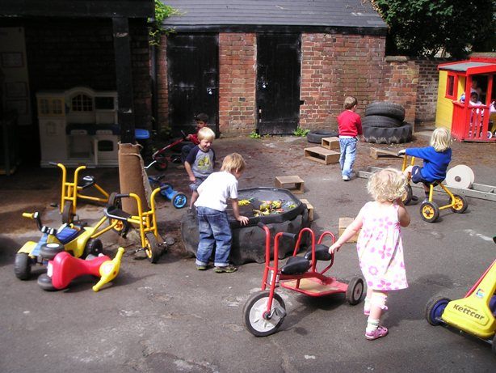 | At Sutton Bonington Pre-school Playgroup your child will discover a safe and caring environment full of fun and stimulating activities.  Our focus on learning through play will enable your child to develop and extend new skills, building friendships and self confidence.  Our staff are qualified in early years care and education and regularly update their skills. A list of staff is provided at the end of this prospectus.

OUR AIMS

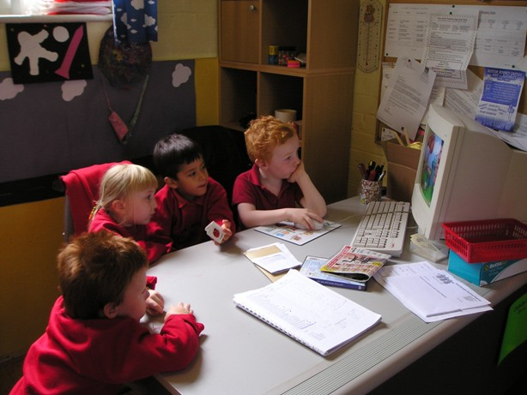 | We offer a child-centred learning environment where children feel safe to explore, experiment and have fun. We combine traditional values with an up-to-date and interesting curriculum.
We aim to:
- provide high quality care and education for children between 2 and 5 years;
- work in close partnership with parents to help children to learn and develop;
- play an active role in our local community and maintain our excellent reputation within the area;
- offer children and their parents a service which promotes equality and values diversity.

We offer your child:

- a safe and stimulating environment
- a specially tailored curriculum following the Early Years Foundation Stage
- individual care and attention, because of our high ratio of adults to children
- fun and friendship with other children and adults
- a key person who takes a special interest in his/her progress

Our playgroup is registered with Ofsted and our last inspection reported that we had a GOOD standard of provision with ”children benefitting from a welcoming and inclusive setting in a friendly environment”. Ofsted report

EARLY YEARS FOUNDATION STAGE

The Early Years Foundation Stage (EYFS) is the statutory framework which sets the standards all Early Years providers must meet to ensure that children learn and develop effectively and are kept healthy and safe. It promotes teaching and learning to ensure children are provided with the knowledge and skills for good future progress through school and life.

Children start to learn about the world around them from the moment they are born. The EYFS divides children’s learning and development into three prime areas:

- communication and language
- physical development
- personal, social and emotional development

And four specific areas:
- literacy
- maths
- understanding the world
- expressive arts and design

Communication and language
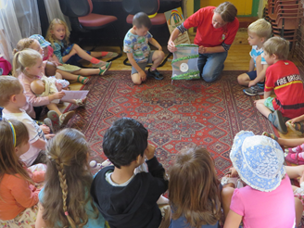 | Each day children take part in storytime and group discussions, learning to talk with and listen to others, both in small and large groups.  Many of our daily activities are linked with child-initiated topics for the term.
Physical development  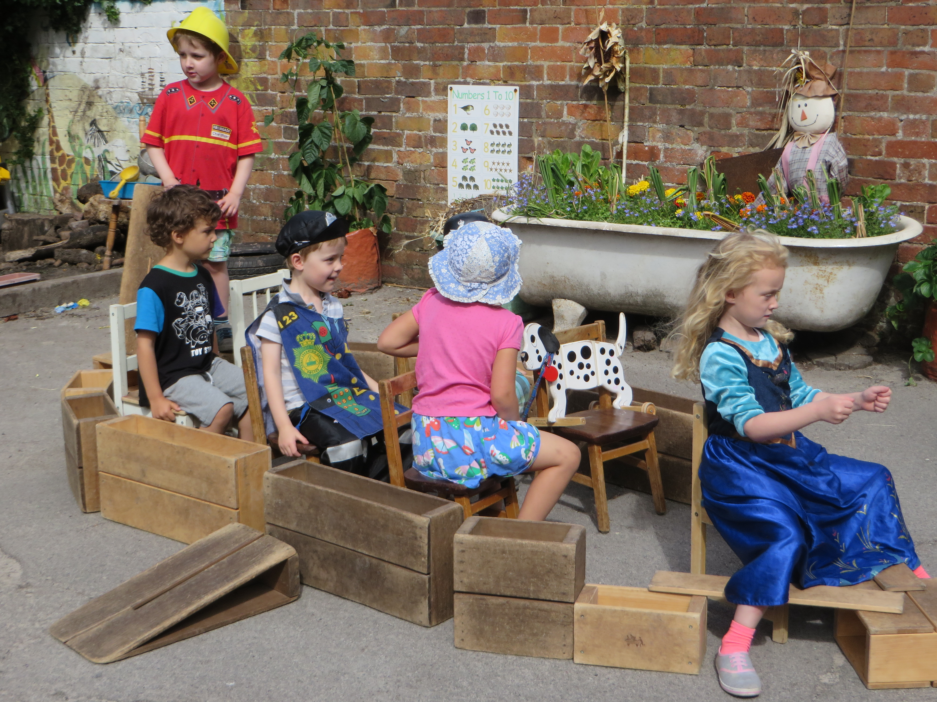 | Outside play is a daily activity in all weathers and children enjoy space to run, hop, skip and jump. Apparatus is available to help the children develop climbing skills and to co-ordinate balance and control.  Activities are provided to develop fine motor skills such as hand control by picking up and using small objects and tools.

Personal, social and emotional development
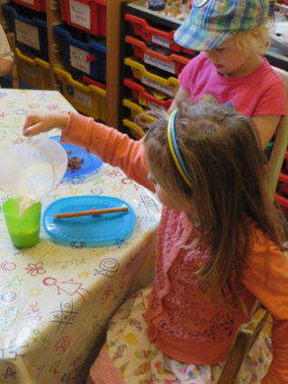 | The Pre-school Playgroup encourages children to gain skills which help them to be independent.  Our activities are designed to help children build self esteem and have a positive and confident approach to learning.  Each day the children and staff have a snack and social time.

Literacy

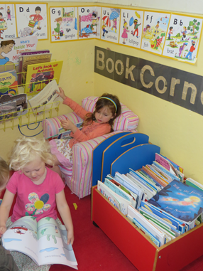

We have a book corner where children can read books and have a book read to them in groups. We also have a library system where children choose a book to take home and return it the following week to swap as well as regular trips to the local library.

Maths

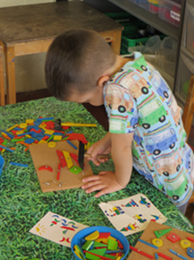 | Our daily activities are designed to help the children learn and build up ideas about numbers, shapes and patterns. The activities also introduce the children to finding results by using numbers to count, add and take away.

Knowledge and understanding of the world

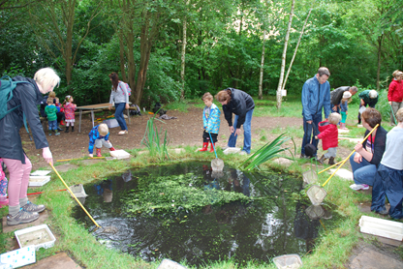 | Children enjoy outings and activities organised to help them learn about their local area, the world and how it works. They contribute to discussions about past, present and different cultures.  We celebrate a variety of multicultural festivals.

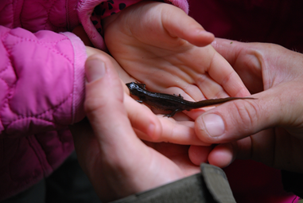 | We run regular Forest School sessions at playgroup. The philosophy behind Forest School is to encourage and inspire children through positive outdoor experiences. We regularly visit our local spinney and take part in activities such as den building, bug hunts and making things with natural materials.

Expressive arts and design
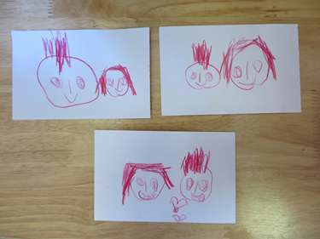 | Each day the children have the opportunity to use a variety of materials to create art work.  An area of the Play group is designated for role play with ample equipment and dressing-up clothes for the children to use.  Staff and children share music to which they sing, listen, dance and play instruments.

WORKING TOGETHER FOR YOUR CHILDREN

We have a high ratio of adults to children in the setting. This helps us to:

- give time and attention to each child
- talk with the children about their interests and activities
- help children to experience and benefit from the acitivities we provide
- allow the children to explore and be adventurous in safety.

KEY PERSON

When your child starts at Sutton Bonington Pre-school Playgroup they will be allocated a key person. This member of staff will have particular responsibility for your child including completing their Learning Journey which records their progress at playgroup through observations, photos and examples of their work.

LEARNING JOURNEY

Your child’s key person will frequently observe their development in all areas of the EYFS. Their Learning Journey celebrates and records their achievements and enables the key person to work with you to plan for your child’s Next Steps for development.

ADMISSIONS
We aim to ensure that all members of our community have access to the pre-school and we welcome children from all surrounding areas.
We accept children from their second birthday and operate a waiting list if there are no vacancies.

We accept children in nappies/pull-ups; parents must supply sufficient numbers of nappies and baby wipes to enable staff to change your child.

For enquiries about admissions please contact our playgroup Administrator at info@suttonboningtonplaygroup.org

PARENTAL FEES

Nottinghamshire County Council will pay for 15 hours childcare per week for children who are 3 (starting from the term after they turn 3). From September 2017 some parents will be eligible to 30 hours funding and tax free childcare vouchers. The link to apply is https://childcare-support.tax.service.gov.uk/par/app/applynow

Some 2 years old children may be eligible for funding if their parents/carers are in receipt of certain benefits. This needs to be claimed directly by the parent from Nottinghamshire County Council. Parents can choose where to “spend” this funding and can split it between two providers if they choose. Funding money can be used to pay for Playgroup sessions and for lunch clubs.
Our charges are as follows:

- £16.50 per morning session (3hrs) for non-funded children
- £33 per full day (6hrs) for non-funded children
- £5.50 Lunch-club

These figures are kept under review to ensure that we have sufficient income to meet our outgoings, in particular staff and rent costs.
THE MANAGEMENT OF SUTTON BONINGTON PRE-SCHOOL PLAYGROUP

A parent committee, whose members are elected by the parents of the children who attend the pre-school, manage the setting. The elections take place at the Pre-school Playgroup Annual General Meeting held in October each year. The committee is responsible for:

- managing the pre-school’s finances
- employing and managing the staff
- making sure that the pre-school has – and works to – policies which help it to provide a high quality services
- making sure that the pre-school works in partnership with the children’s parents
- Keeping parents informed through regular newsletters.
The Annual General Meeting is open to the parents and carers of all of the children who attend the pre-school. It is their forum for looking back over the previous year’s activities and shaping the coming year’s activities. For up to date members of the committee please see the notice board at playgroup.

If you wish to contact the Chair or any member of the committee please ask a member of staff to ask them to contact you or e-mail info@suttonboningtonplaygroup.org. Should you wish to find out more or see us in action, please contact us on 07977 545702 or have a look at our website: www.suttonboningtonplaygroup.org

We look forward to welcoming you and your child!

Sutton Bonington Pre-school Playgroup is a registered charity number 1036486

Playgroup Staff

Name | Position | Qualification
Sarah Cowley | Playgroup Leader & Toddler Group Leader | Level 3 Early Years
Natalie Howard | Deputy Playgroup Leader | Level 5 Early Years
Julia Wilks | Playgroup Practitioner | Level 3 Early Years
Rachel Hudson | Playgroup Practitioner | QTS
Anne-Marie Preece | Playgroup Assistant | Level 3 Early Years
Aimee Rudd | Playgroup Assistant | Level 3 Early Years

Days and Opening Times

Day | Times
Monday | 9am- 3pm
Tuesday | 9am- 3pm
Wednesday | 9am- 3pm  & 2-3yr old session  9-12pm
Thursday | 9am- 3pm  & 2-3yr old session  9-12pm
Friday | 9am-12noon & Lunch club 12- 1pm

